Web Development – Mr. Turner

Level 2 Project – Bug Splat

**Project Overview**

The client will be able to splatter bugs while they make pleas for mercy.

**The Site**

There are 15 images of a bug on the screen and a message along the bottom. You may use any bug images you like. You do not need to follow the pictured example.

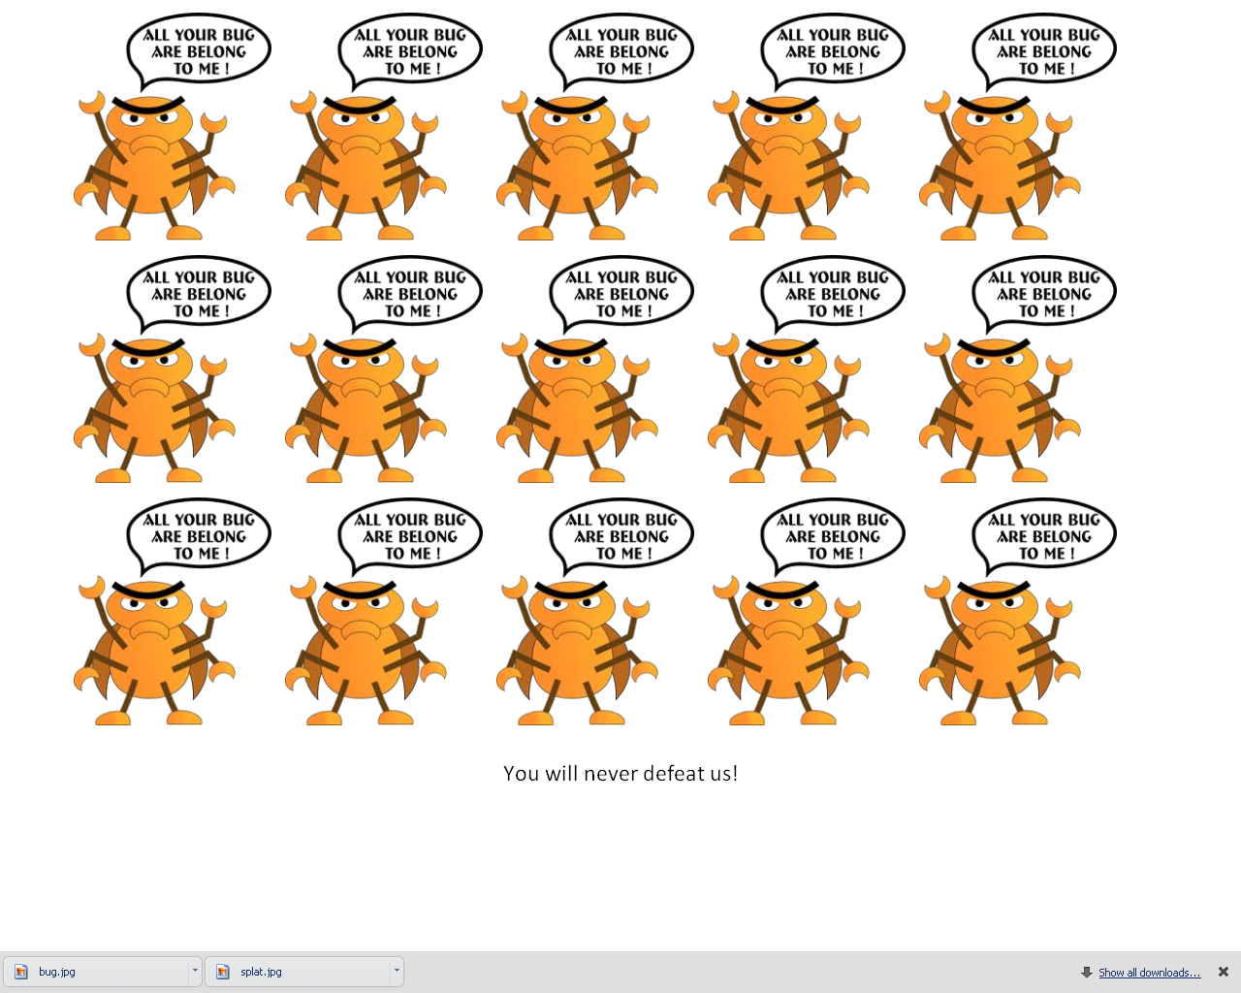

The opening message is “You will never defeat us.”

Each time the user clicks on a bug, the image will change to a splatter image and the message will change.

Create random comments so that the bugs say something different after each splat. The comments, however, should become more dire after the 8th bug so that a plea for mercy wouldn’t happen while there are still 12 bugs on the screen. After the last bug is squashed, the message will read “You’ve killed us all.”

No comment should ever be displayed twice.

The order in which the comments are displayed should change each time the program is run (they’re displayed in a random order).

After every other bug squash, the message will read “Ouch!”

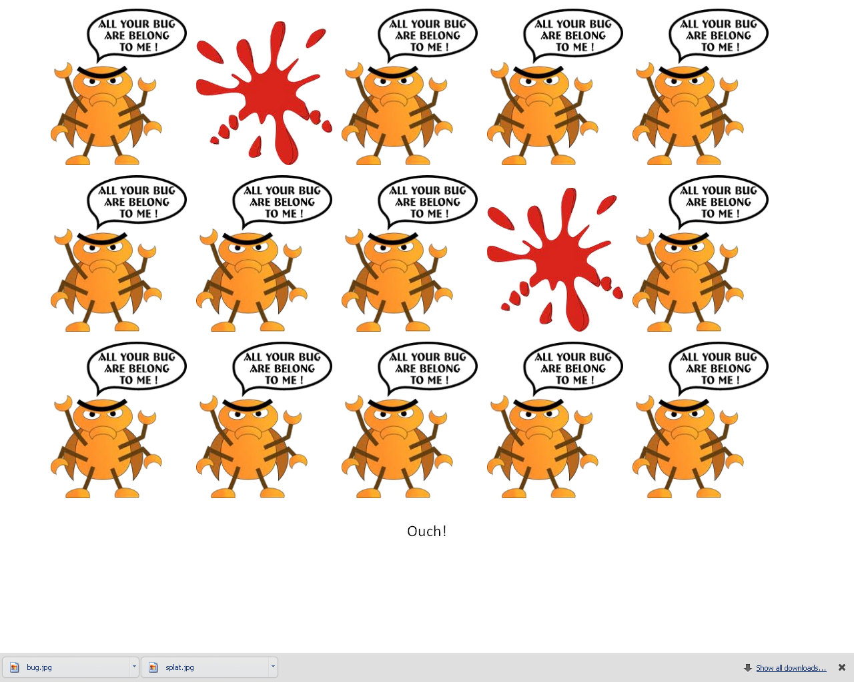

**Bonus**

Make it so that, after the 8th bug is splatted, the bugs gains the ability to come back. After each splat, there is a 10% chance that one of the dead bugs will return.

After the last bug is splatted, the screen will change to show a big picture of a scary bug. The comment will read, “That’s it. Now Mamma’s angry!”

**Programming Requirements**

|  |
| --- |
| * You must write all of your own code. Use of a drag and drop interface or the usage of code downloaded from the internet is not permitted. |
| * Use of deprecated code is not permitted. |
| * Your home page must be named *index.html*. |
| * You must comment your name into the top of every page, but below the doctype. |
| * Your code must be structured in a consistent and legible manner. |
| * Your interface must be smooth and easy to figure out for a client. |

*You project is to be submitted via Moodle. Compress all of the necessary files into a zip file.*